Present time zombie apocalypse

All players are in a movie theater watching the newest star wars movie. Just out of nowhere you hear screams outside and hear run people are getting crazy and eating each other.

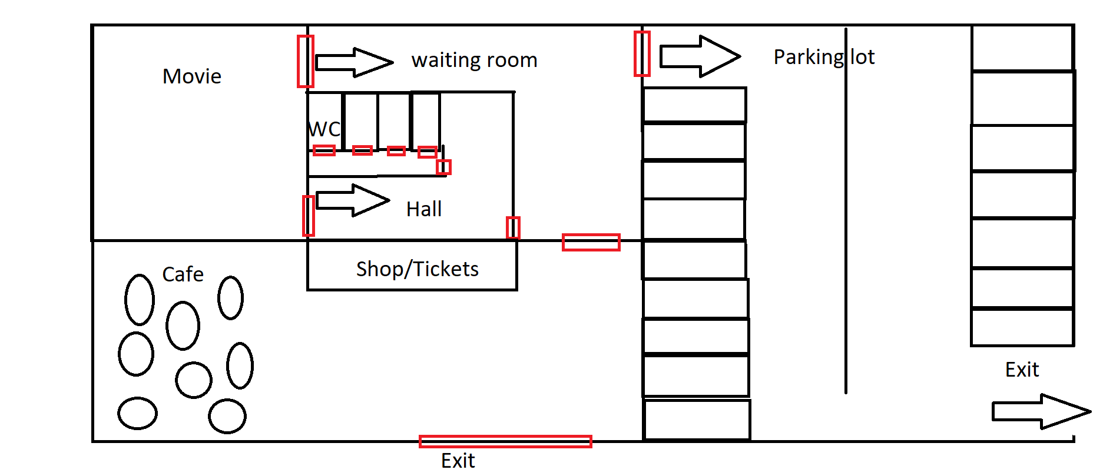

The escape

**Waiting room** is dense but can use people to your advantage, hall is less crowded, but will encounter a zombie.

**Parking lot** you can meet other people and get help, you can also encounter other people that ask for help.

People you can meet. Pregnant women that gets bitten

An asshole of a man that is in front with his car and rides over the just bitten pregnant women

Bitten child, but you don’t know of it because she hides it.

You can use 1 car if you steal it form a human else you will stay on foot

**The normal exit:** people will fight each other while escaping, zombies will be in front of the exit. 1 man will try to get the lead, will the players listen to it.

Going to the hospital

Road blocked and forced to go to on foot.

Items that can be found

Purse, wooden stick, steel stick, 1 time use of other worldly stuff

**Zombies can’t see but only hear**